**Vibrational Spectroscopy**

RAMAN Signal Processing

**RAMAN Automated Signal Processing Application (RASPA)**

User Manual

Luke Melo  
Research Associate | Grant Group  
Department of Chemistry | University of British Columbia  
2036 Main Mall | Vancouver, BC Canada V6T1Z1  
Phone 1-(604)-827-4562 | Cell 1-(226)-972-5853  
[lrmelo@uwaterloo.ca](https://www.nexusmail.uwaterloo.ca/horde_3.3.5/imp/message.php?mailbox=INBOX&index=3107) | [melo.luke@gmail.com](https://www.nexusmail.uwaterloo.ca/horde_3.3.5/imp/message.php?mailbox=INBOX&index=3107)

Table of Contents

[Application Overview and Goals 2](#_Toc396916157)

[Starting the Application 3](#_Toc396916158)

[Opening File Data 5](#_Toc396916159)

# Application Overview and Goals

This user manual outlines the main features and functionality of the RAMAN Automated Signal Processing Application (RASPA). RASPA is meant to facilitate RAMAN data acquisition by automating chemometric algorithms developed for high frequency noise and fluorescence background subtraction. Weak fluorescence from the analyte and immersion oil on the camera objective can be much stronger than RAMAN scattering, which can result in a large background fluorescence overwhelming the RAMAN light[[1]](#footnote-1). In the past, background fluorescence rendered RAMAN spectroscopy inferior to FTIR spectroscopy as an analytical technique. However, with the application of high frequency noise and fluorescence background subtraction algorithms, RAMAN spectroscopy becomes more reliable as an analytical technique because it improves significantly on the signal to noise ratio (SNR).

# Starting the Application

1. A desktop shortcut to RASPA can be used to open the app. Double click the icon to open the LabVIEW project file.

* Documents\LabVIEW Data\iSCAT LabVIEW Project Files\Waveform Processing Labview\Waveform Processing Hub.lvproj

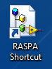

Figure 1 - RASPA Shortcut

1. Once LabVIEW completes booting, a Project Explorer window will appear containing the RASPA VI’s and sub VI’s. Double click ‘Waveform Processing Hub.vi’ to open the VI.

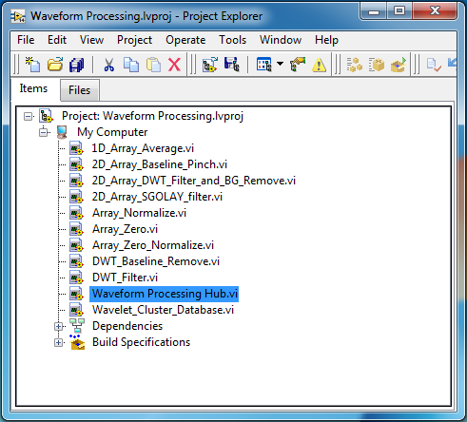

Figure 2 - LabVIEW Project Explorer

1. Since the DWT sub VIs use the MATLAB Signal Processing Toolbox, a MATLAB Command Window will appear on the screen. This may take a few moments so be patient.

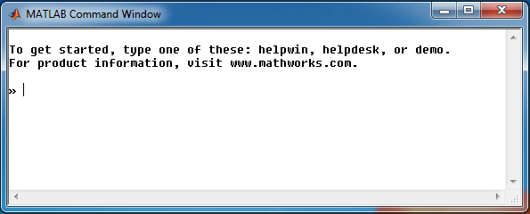

Figure 3 - MATLAB Command Window

1. Once the MATLAB Command Window has opened, the RASPA front panel will open.

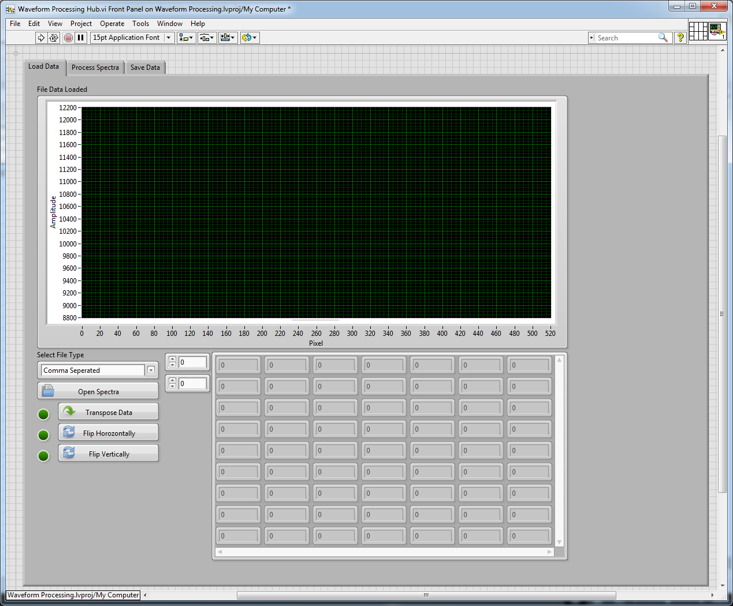

Figure 4 - Waveform Processing Hub.lv Front Panel

# Opening File Data

1. The first step is to run the VI:

C:\Users\User\Dropbox\Manual Screens\2014-08-27 14_18_14-Waveform Processing Hub.vi Front Panel on Waveform Processing.lvproj_My Computer.png

Figure 5 - Run VI

1. Select your file formatting. RASPA will process .txt or .csv files formatted as:

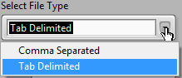

Figure 6 - File Data Formatting Options

* 1. Tab Delimited [‘\t’]

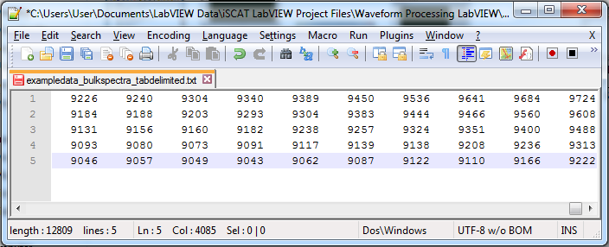

Figure 7 - Tab Delimited Example File [5 Spectra]

* 1. Comma Separated [‘,’]

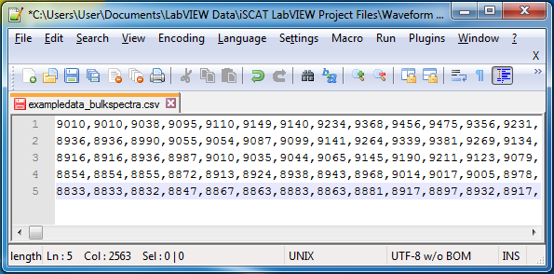

Figure 8 - Comma Separated Example File [5 Spectra]

1. Click the ‘Open Spectra’ button to import your file data into RASPA. RASPA is capable of bulk spectra processing. Organize the file data into row vectors as shown in figures 7 and 8.

C:\Users\User\Dropbox\Manual Screens\2014-08-27 15_09_51-Waveform Processing Hub.vi.png

Figure 9 - Open Spectra Button

1. An explorer window will pop up. Locate your file data and click ‘OK’ to import.

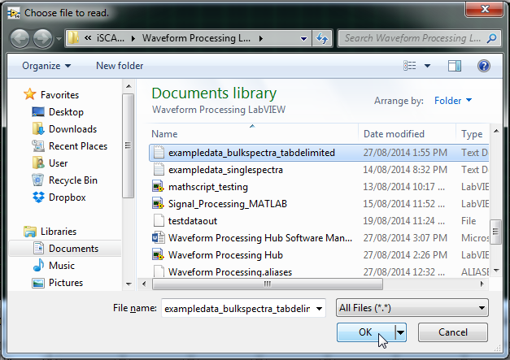

Figure 10 - 'Choose file to read.' Explorer Window

1. *Anal. Chem.* **1994**, *66*, 4159-4165 [↑](#footnote-ref-1)